|  |  |  |
| --- | --- | --- |
|  | Project Design Phase – II | |
| Solution Requirements (Functional & Non-Funcitonal) | | |
|  |  |  |
| Date |  | 31 October 2022 |
|  |  |  |
| Team ID |  | PNT2022TMID49645 |
|  |  |  |
| Project Name |  | Classification of Arrhythmia using Deep Learning |
|  |  | with 2-D ECG Image |
|  |  |  |

**Dataflow Diagram:**

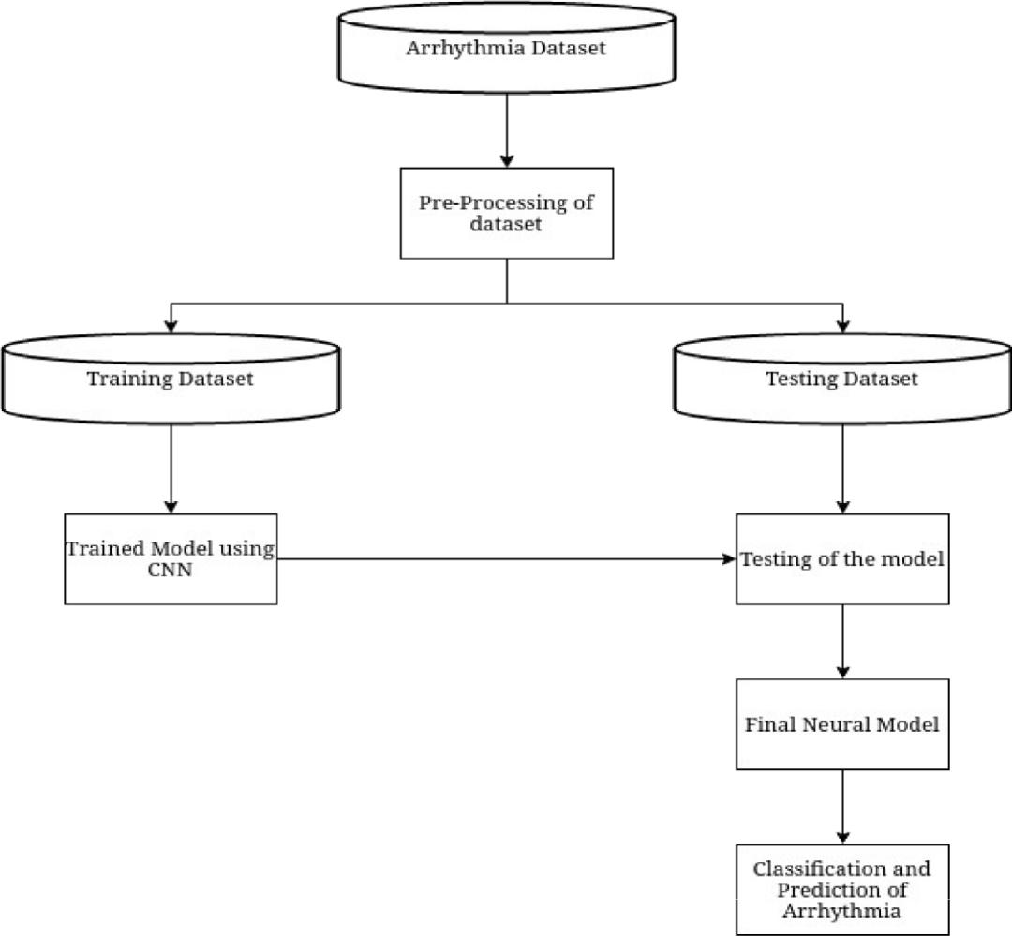

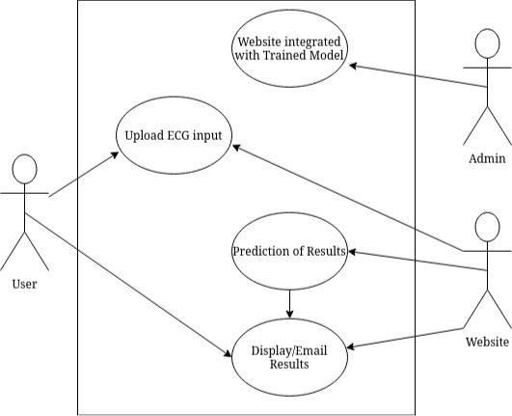

|  |  |  |  |  |  |  |
| --- | --- | --- | --- | --- | --- | --- |
| User Type | Functional | User | User | Acceptance | Priority | Release |
|  | Requirement | Story | Story/Task | Criteria |  |  |
|  | (Epic) | Number |  |  |  |  |
|  |  |  |  |  |  |  |
| Customer | Registration | USN-1 | As an user I an | I can access | High | Sprint-1 |
| (Web User) |  |  | register an | classification page |  |  |
|  |  |  | account in the |  |  |  |
|  |  |  | webiste |  |  |  |
|  |  |  |  |  |  |  |
|  | Login | USN-2 | As an user I can | I can access | High | Sprint-1 |
|  |  |  | login into the | classification page |  |  |
|  |  |  | website using |  |  |  |
|  |  |  | credentials |  |  |  |
|  |  |  |  |  |  |  |
|  | Arrhythmia | USN-3 | User uploads the | Input for the | High | Sprint-1 |
|  | Classification |  | data | model |  |  |
|  | page |  |  |  |  |  |
|  |  |  |  |  |  |  |

Dashboard

USN-4

Dashboard



displays

information

about

Arrhythmia

User can learn about Arrhythmia

Medium

Sprint-2